The outputs generated while pushing the data fom android app in the device to HBase.

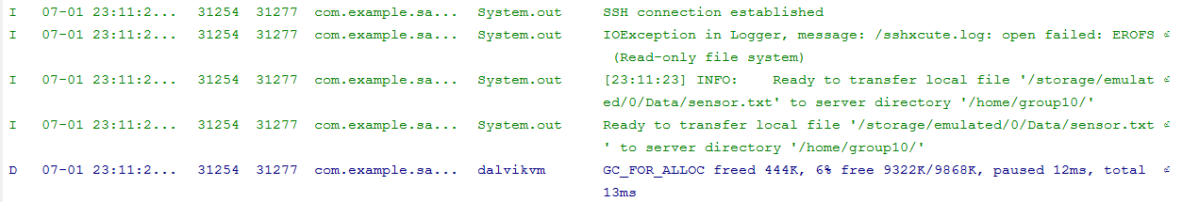

When logged in through putty there it shows the pushed file.

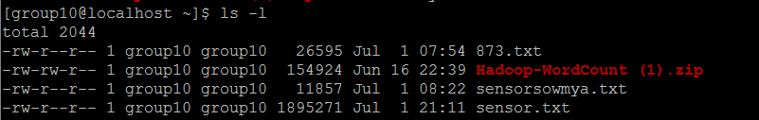

The readings data.

